

Summer Internship Project Report
On
HINDALCO PLANT DATA MANAGEMENT
LOGBOOK SYSTEM
Submitted to
HINDALCO Industries Limited, Muri, Jharkhand– 835101
BY
SOUVIK MAHTO
24030480122
BIT SINDRI DHANBAD
Training Period – 01 Jun 2026 to 01 Jul 2026

 | B.I.T. SINDRI, DHANBAD, JHARKHAND  DEPARTMENT OF HIGHER TECHNICAL EDUCATION, GOVERNMENT OF JHARKHAND | 

CERTIFICATE
This is to certify that Mr. Souvik Mahto, student of B.Tech Information Technology, BIT Sindri, Dhanbad, has successfully completed Summer Internship training at HINDALCO Industries Limited, Muri Works.
During the internship period, he carried out the project entitled “Hindalco Plant Data Management Logbook System” under the guidance of the Information Technology Department as part of the Summer Internship Programme.
The project was undertaken during the period 01 June 2026 to 01 July 2026.
We wish him every success in his future academic and professional endeavors.
Under the Guidance of
Mr. Mehtab Alam  Assistant-Manager, IT Department | Mr. Atul Kumar  Head, IT Department
HINDALCO Industries Limited

ACKNOWLEDGEMENT
I would like to express my sincere gratitude to all the individuals who contributed to the successful completion of the Hindalco Plant Data Management Logbook System during my industrial training at Hindalco Industries Limited.
I am deeply thankful to Mr. Atul Kumar, Head of the IT Department, and Mr. Mehtab Alam , for their valuable guidance, technical support, encouragement, and continuous supervision throughout the project. Their suggestions and industry expertise played a crucial role in shaping the application.
I also extend my heartfelt thanks to the entire IT Department of Hindalco Industries Limited for providing me with a learning-oriented environment and the opportunity to work on a real industrial project.
I would also like to thank BIT Sindri, Dhanbad, and all my faculty members for providing me with the academic foundation and knowledge required to undertake this internship successfully.
The internship has significantly improved my technical skills, problem-solving abilities, and understanding of enterprise-grade software development.
— Souvik Mahto

Abstract
The Hindalco Plant Data Management Logbook System is a web-based industrial application developed to digitize and streamline the process of recording and managing operational plant data. The application replaces traditional paper-based and Excel-based logbooks with a centralized, database-driven solution.
The system has been developed using Oracle APEX, Oracle Database, SQL, PL/SQL, HTML, CSS, and JavaScript. It provides a secure platform for plant operators and supervisors to record daily operational readings, manage logbooks, retrieve historical records, and monitor plant activities efficiently.
The application incorporates department-based access control, plant-wise data segregation, dynamic dashboards, custom authentication, authorization schemes, and interactive reports. Users select their department and plant during login, and the system automatically redirects them to the appropriate operational module.
The system enhances efficiency, improves data accuracy, eliminates redundant manual work, ensures secure storage of operational records, and provides a scalable platform for future industrial digitalization initiatives.
Keywords: Oracle APEX, Oracle Database, PL/SQL, Industrial Automation, Logbook Management, Dashboard, Authorization Schemes, Data Management System.

TABLE OF CONTENTS
Certificate 2
Acknowledgement 3
Abstract 4
Chapter 1 — Introduction 6
1.1 Background 6
1.2 Objectives of the Project 6
1.3 Scope of the Project 7
Chapter 2 — System Analysis 8
2.1 Existing System 8
2.2 Proposed System 8
Chapter 3 — System Design 9
3.1 System Architecture 9
3.2 Technologies Used 9
Chapter 4 — Database Design 11
4.1 Database Architecture 11
4.2 Application Items 11
Chapter 5 — System Implementation 12
5.1 Custom Login Page 12
5.2 Dashboard Module 12
5.3 Application Items Management 13
5.4 Application Process Framework 14
5.5 Authorization and Security Framework 14
5.6 Logbook Entry Management Module 15
5.7 Log Management Module 16
5.8 Plant-Wise Data Segregation 17
Chapter 6 — Results and Benefits 18
Chapter 7 — Conclusion 19
Chapter 8 — Future Scope 20
References 21

Chapter 1 — Introduction

1.1 Background
Industrial plants generate a large volume of operational data every day. Traditionally, these readings are recorded using paper registers, spreadsheets, and manually maintained logbooks. Such methods often lead to the following limitations:
- Data redundancy
- Human errors
- Lack of centralized storage
- Difficulty in retrieving records
- Increased paperwork
- Inefficient reporting
To overcome these limitations, a centralized digital logbook management system was required. The Hindalco Plant Data Management Logbook System was developed to provide a secure, user-friendly, and centralized solution for operational data recording and management.

1.2 Objectives of the Project
The primary objectives of the project are:
- Digitize plant logbook management.
- Eliminate paper-based record maintenance.
- Centralize operational data storage.
- Provide department-wise access control.
- Support multiple plant locations.
- Improve data reliability and security.
- Simplify record retrieval.
- Enhance operational efficiency.
- Provide interactive dashboards and reports.
- Create a scalable platform for future expansion.

1.3 Scope of the Project
The project scope includes:
- User authentication
- Department selection
- Plant selection
- Dashboard management
- Logbook entry
- Historical log retrieval
- Interactive reports
- Authorization-based access control
- Multi-plant support
- Centralized database storage

Chapter 2 — System Analysis

2.1 Existing System
Prior to implementation, plant records were maintained using Excel spreadsheets, paper registers, and department-level files. This approach presented several limitations:
- Manual data entry
- Difficulty in searching records
- No centralized database
- Increased risk of data loss
- Poor data consistency
- Difficult report generation

2.2 Proposed System
The proposed system provides a centralized web application capable of storing and managing operational data efficiently. The overall system flow is illustrated below.

System Flow
User Login
↓
Department Selection
↓
Plant Selection
↓
Dashboard
↓
New Log Entry
↓
Database Storage
↓
Log Retrieval & Reports

Advantages
- Centralized management
- Real-time data access
- Improved security
- Reduced paperwork
- Better reporting capabilities
- Multi-plant support

Chapter 3 — System Design

3.1 System Architecture
The application follows a layered architecture that guides the operator from authentication through to reporting, as shown below.
Operator / User
↓
Custom Login Page
↓
Department & Plant Selection
↓
Dashboard
↓
Log Entry Module
↓
Oracle Database
↓
Interactive Reports

3.2 Technologies Used
Technology | Purpose
Oracle APEX | Used for rapid web application development.
Oracle Database | Used for centralized storage of operational data.
SQL | Used for querying and managing database records.
PL/SQL | Used for implementing business logic and automation processes.
HTML | Used for page structure and custom layouts.
CSS | Used for user interface design and styling.
JavaScript | Used for client-side interactions and dynamic behavior.

Chapter 4 — Database Design

4.1 Database Architecture
The application follows a Header–Detail database architecture, separating shift-level context from detailed operational measurements.

Header Tables — Store
- Log Date
- Shift Code
- Plant Code
- User Details
- Remarks

Detail Tables — Store
- Operational Readings
- Equipment Parameters
- Tank Information
- Process Measurements

4.2 Application Items
The application uses Oracle APEX Application Items to maintain session state across pages.

Key Application Items
- G_USER_DEPT
- G_USER_PLANT
- G_USER_ROLE
- G_ENTRY_PAGE
- G_LOG_PAGE
These variables are used for the following purposes:
- Department management
- Plant filtering
- User authorization
- Navigation control
- Session management

Chapter 5 — System Implementation

5.1 Custom Login Page
The application provides a customized login page where users enter their username, password, department, and plant. After successful authentication, the selected department and plant are stored in session-level application items.

Features
- Secure authentication
- Department selection
- Plant selection
- Dynamic redirection
- User-friendly interface
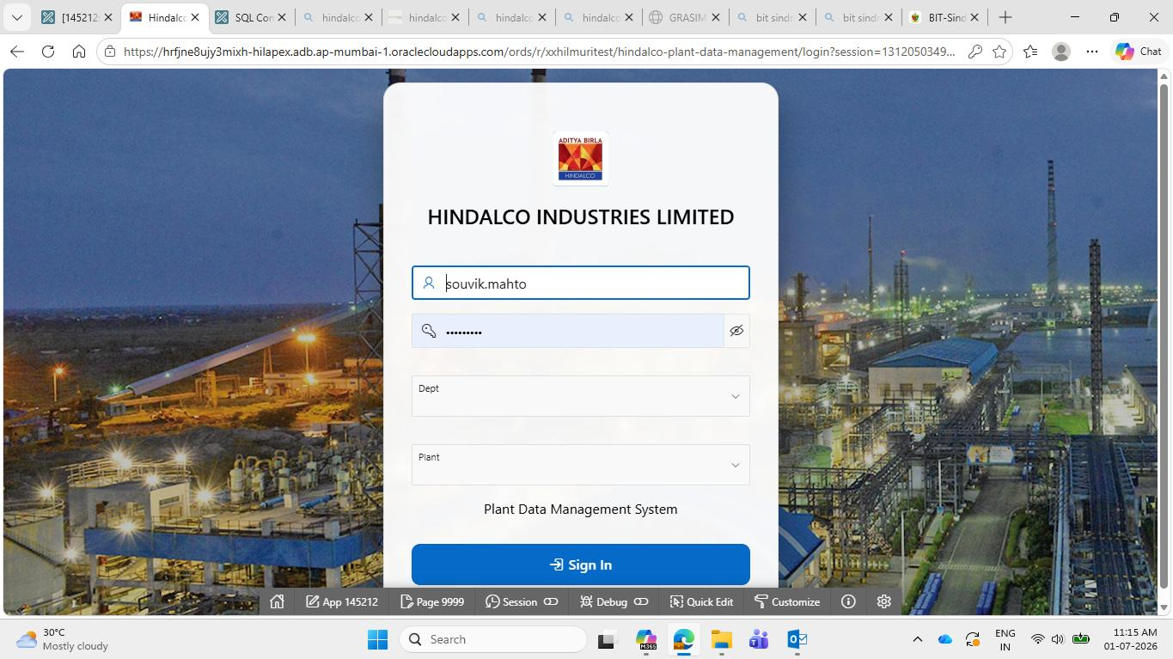
Figure 5.1: Custom Login Page

5.2 Dashboard Module
The Dashboard serves as the primary navigation interface of the application, providing department, plant, and user information along with quick-action cards.

Features
- Modern UI design
- Dynamic navigation
- Quick-action buttons
- Department-aware functionality
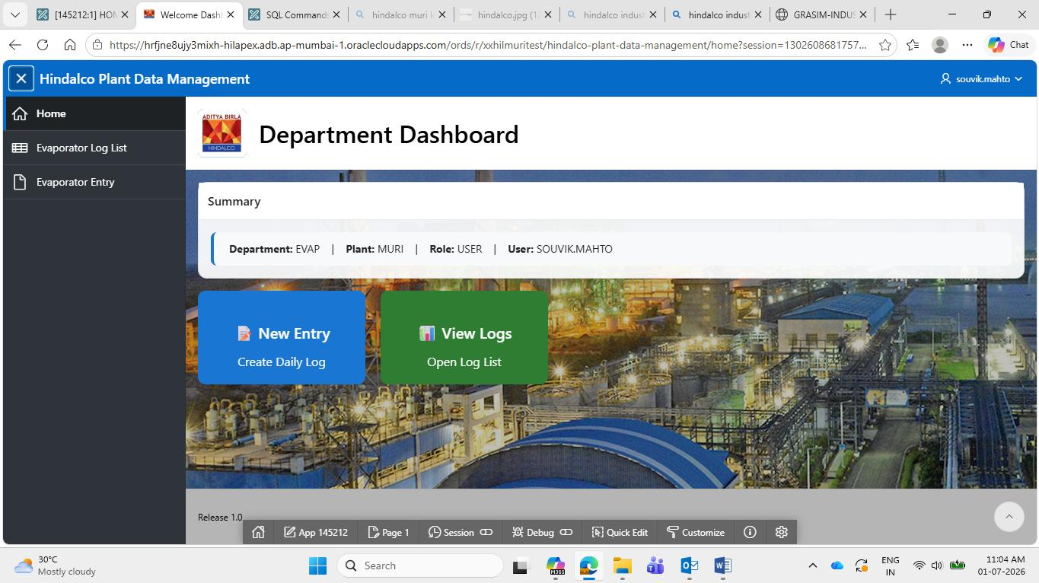
Figure 5.2: Dashboard Page

5.3 Application Items Management
Application Items are used to maintain user context across all pages, including G_USER_DEPT, G_USER_PLANT, and G_USER_ROLE. These values are set immediately after login and used throughout the application.

Benefits
- Centralized session management
- Easy navigation control
- Simplified authorization logic
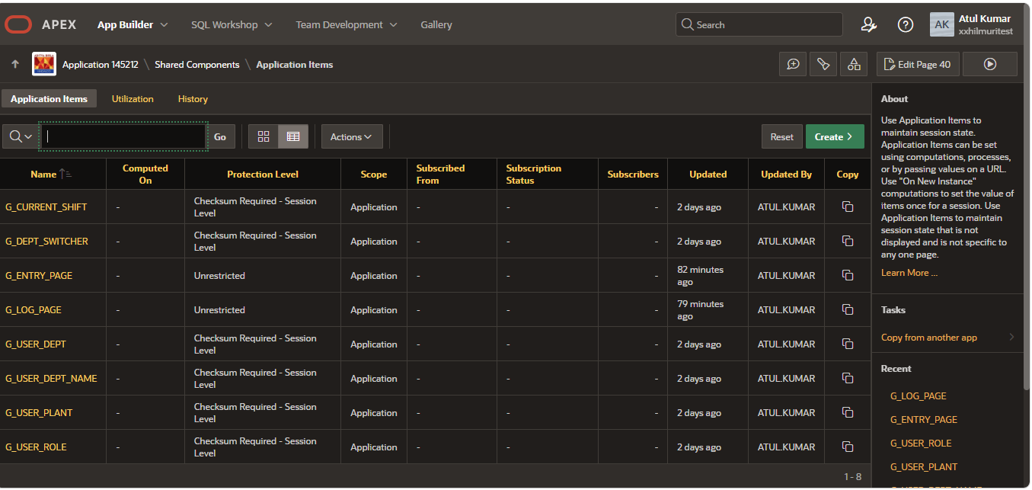
Figure 5.3: Application Items

5.4 Application Process Framework
The system uses centralized application processes for handling navigation and session initialization.

Global Department Switcher — Responsibilities
- Store department selection
- Store plant selection
- Set user role
- Configure navigation parameters

Auto Redirect By Department — Responsibilities
- Redirect users automatically
- Open department-specific modules
- Improve user experience
Department Code | Module Opened
PRECIP | Precipitator Module
EVAP | Evaporator Module
HTD | HTD Module
SEED_85A | Seed 85A Module
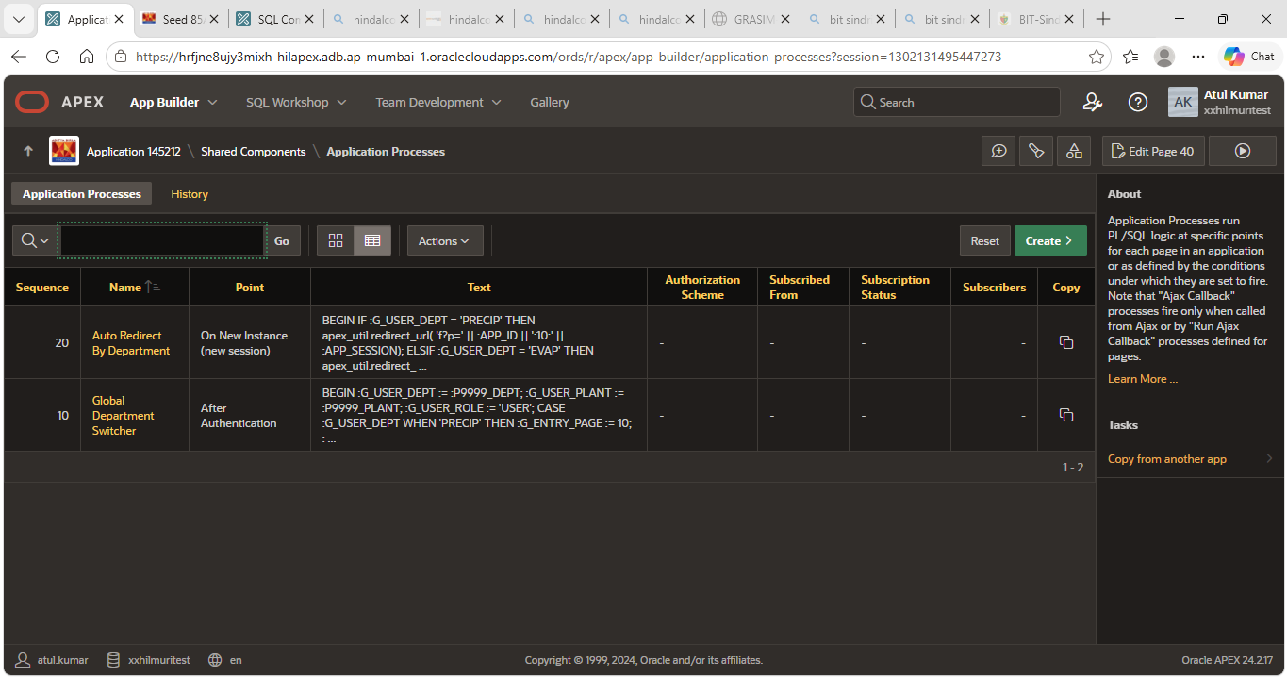
Figure 5.4: Application Processes

5.5 Authorization and Security Framework
The application uses Authorization Schemes to control access to department-specific modules:
- Is Precip Dept User – Provides access only to Precipitator pages.
- Is Evap Dept User – Provides access only to Evaporator pages.
- Is HTD Dept User – Provides access only to HTD pages.
- Is Seed Dept User – Provides access only to Seed 85A pages.

Security Features
- Page-level security
- Menu-level security
- Department isolation
- Session-based authorization
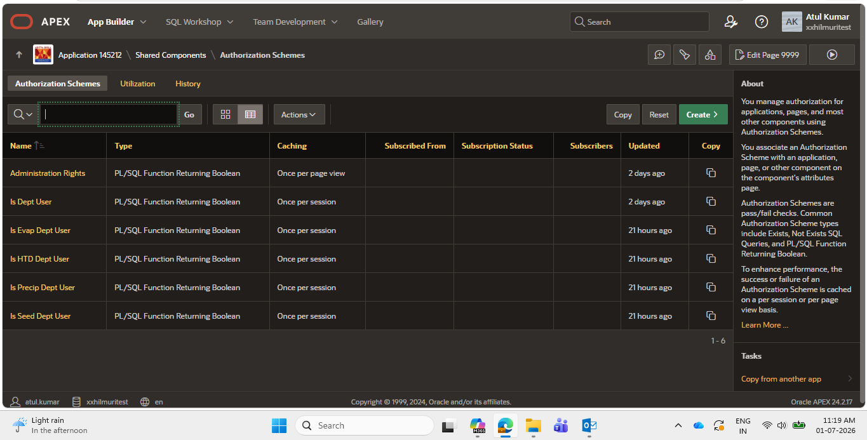
Figure 5.5: Authorization Schemes

5.6 Logbook Entry Management Module
The Logbook Entry Module allows plant personnel to record daily operational data, including date, shift, plant, equipment readings, process parameters, and remarks. The system uses Interactive Grids for efficient data entry and modification.

Features
- Structured data entry
- Interactive grids
- Real-time validation
- Easy editing
- Centralized storage
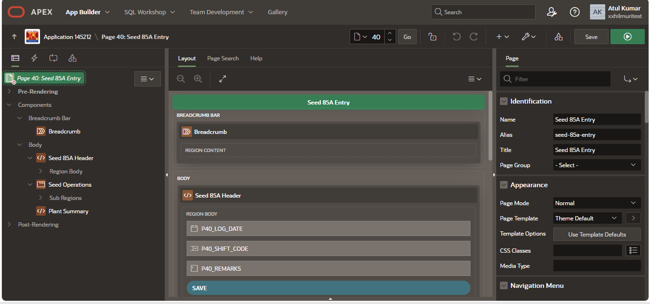
Figure 5.6(a): Logbook Entry Page Structure (Page Designer)
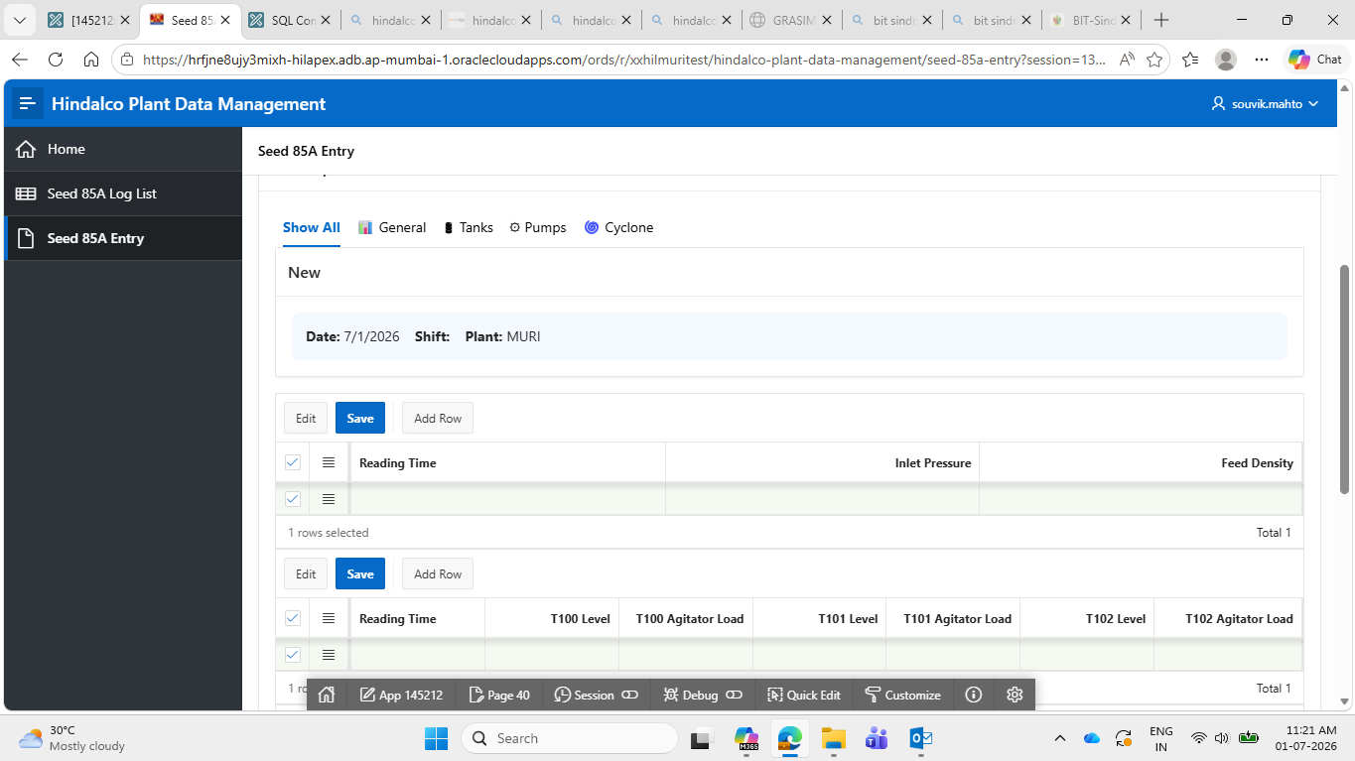
Figure 5.6(b): Logbook Entry Screen (Runtime)

5.7 Log Management Module
The Log Management Module provides historical access to stored records. Users can search, review, filter, and edit existing entries.

Information Displayed
- Log ID
- Log Date
- Shift Code
- Plant Code
- Creation Date

Features
- Interactive reports
- Search functionality
- Data filtering
- Historical tracking
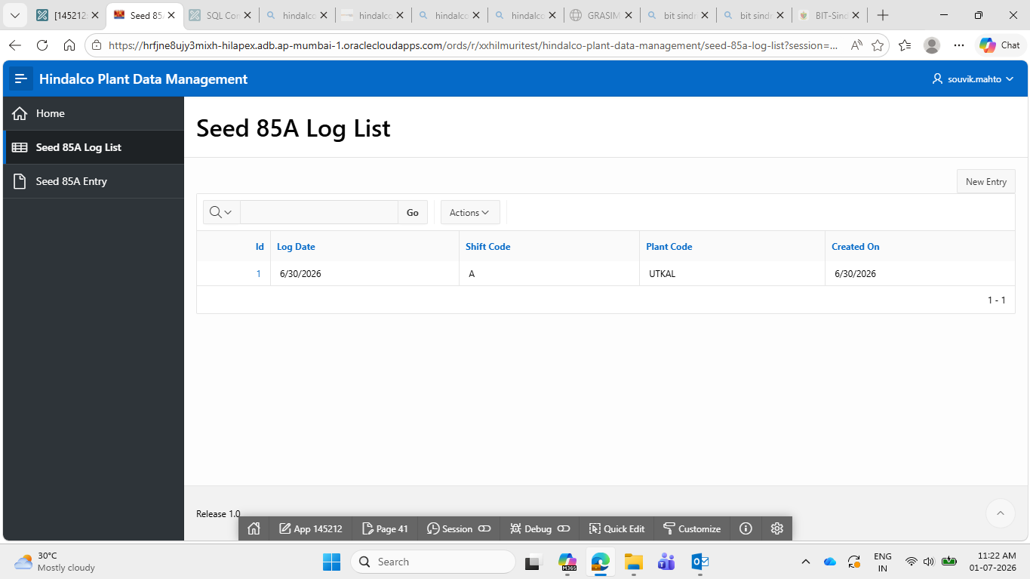
Figure 5.7: Log List Report

5.8 Plant-Wise Data Segregation
The application supports multiple plant locations — MURI and UTKAL — using a common database architecture. Each record stores a PLANT_CODE, and users only see records corresponding to the plant selected during login.

Advantages
- Single database maintenance
- Multi-plant support
- Reduced complexity
- Controlled data visibility

Chapter 6 — Results and Benefits
The developed system provides several measurable operational benefits:
- Reduction in paperwork
- Improved data accuracy
- Secure centralized storage
- Faster record retrieval
- Plant-wise data management
- Department-wise access control
- Improved monitoring capabilities
- Better operational efficiency
- Simplified reporting

Chapter 7 — Conclusion
The Hindalco Plant Data Management Logbook System successfully digitizes the process of maintaining industrial logbooks. The project replaces manual record management methods with a centralized Oracle APEX-based web application.
The system incorporates secure authentication, department-wise authorization, plant-wise data segregation, interactive dashboards, centralized storage, and efficient data retrieval mechanisms.
The application provides a reliable, scalable, and user-friendly platform that supports operational efficiency and digital transformation initiatives within Hindalco Industries Limited.

Chapter 8 — Future Scope
The system can be enhanced further by implementing:
- Mobile application support
- PDF report generation
- Excel export functionality
- Email notifications
- Workflow approvals
- IoT sensor integration
- Power BI dashboards
- Advanced analytics
- Multi-plant expansion
- Cloud deployment
These enhancements can further improve industrial data management and operational visibility.

References
1. Oracle APEX Documentation.
2. Oracle Database Documentation.
3. Oracle PL/SQL Language Reference.
4. Oracle SQL Language Reference.
5. Oracle APEX Tutorials and Learning Resources.
6. Hindalco Industries Limited Official Website.
7. Elmasri & Navathe – Fundamentals of Database Systems.
8. Silberschatz, Korth & Sudarshan – Database System Concepts.

